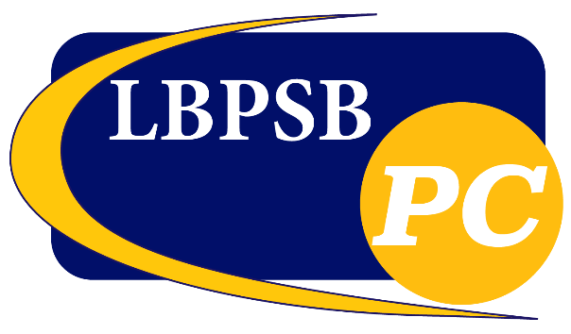**Parents’ Committee MEETING**

**Thursday, may 16, 2024**

**7:00 p.m., @1924 Brookdale Ave.**

**AGENDA**

In person reception with snacks and refreshments

1. Call to Order with Land Acknowledgement
2. Word from the Chair
3. Approval of the Minutes
4. Approval of the Agenda
5. Correspondence
6. Questions from the Public
7. Presentation by Lisa Lorenzetti, Spokesperson for Alloprof

Topic: Resources offered by Alloprof

1. New Business
   1. CONSULTATION: Consultation on Equity, Diversity, Dignity, and Inclusion Policy
   2. Calendar Options for 2025-2026
2. Council and External Reports
   1. Council of Commissioners
   2. Administration
   3. SNAC
   4. EPCA
3. Breakout Discussions with Regional Directors
4. Adjournment